**21765_Final_Project**

**Description:** This project attempts at building a windows desktop application for calculating strain energy in a structure, based on results from finite-element analysis software Bentley STAADpro. Visual Basic programming language is used for creating the application due to support for parallel processing features and author’s familiarity with syntax from prior exposure to Visual Basic for Applications (VBA). The application also uses multi-threading to extract data from the analysis software by use of parallel *for* loops. There were multiple options to incorporate multi-threading such as parallel extraction of beam information for a given load case or parallel extraction of beam information for multiple load cases for a given beam. Latter approach was adopted for simplicity. The tool also required the use of a background worker object to execute computation of strain energy on a separate thread and keep the GUI thread free for interaction with the user. Listed references at the end of this document were used for implementing background worker.

**Motivation:** For two structures supporting some external loads and which have the same total material consumption, the structure with lower strain energy is preferred as it indicates less deformation under the external loads. Thus, if we can compute strain energy based on the analysis results from a FEM software then the same could be used for comparing two similar structures and identifying the one with lower strain energy. The outcome of this project is such an application which aids user in quickly calculating the strain energy for a structure.

**Assumptions:** Strain energy has multiple components due to different internal forces in the structural member. Formulae for each component is given in Table 1. Since major contributors are bending moment, axial force, and torsion; only these were considered for the calculation of the strain energy in members. Furthermore, the member length is divided into 10 discrete segments and strain energy is assumed to be constant across each segment for simplicity in calculation.

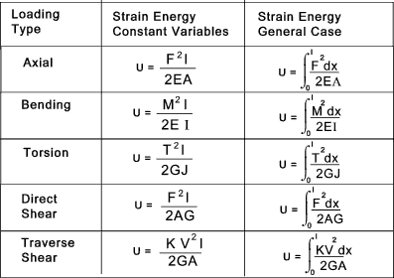

**Table 1: Strain energy due to various internal forces**

**Known Issues:** During development, there was an issue found related to creation of COM object necessary for accessing API commands from STAADpro. Another issue was identified which prevents the update of label related to “Estimated time left” (refer Figure 1). Both are critical issues and need to be resolved.

**How to run the program:**

-> User can run the exe file (created using Visual Studio) from a windows system.

-> Running the exe will open a GUI (refer Figure 1) where the user is supposed to enter information about the load cases which are to be considered for the calculation of strain energy.

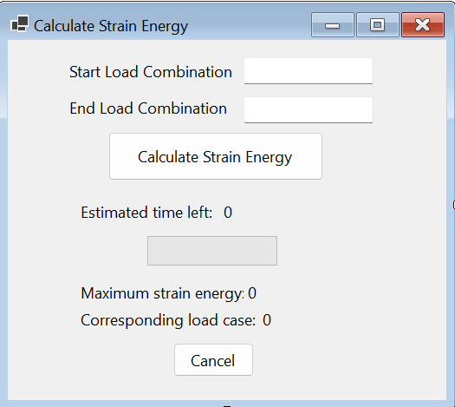

**Figure 1: Tool GUI**

-> The user needs to ensure that the STAAD file containing analysis results for all the load cases is open in the background. This is needed for the API commands to work.

-> User also needs to select all the required structural members (beams) for which the strain energy needs to be calculated (refer red-coloured members in Figure 2).

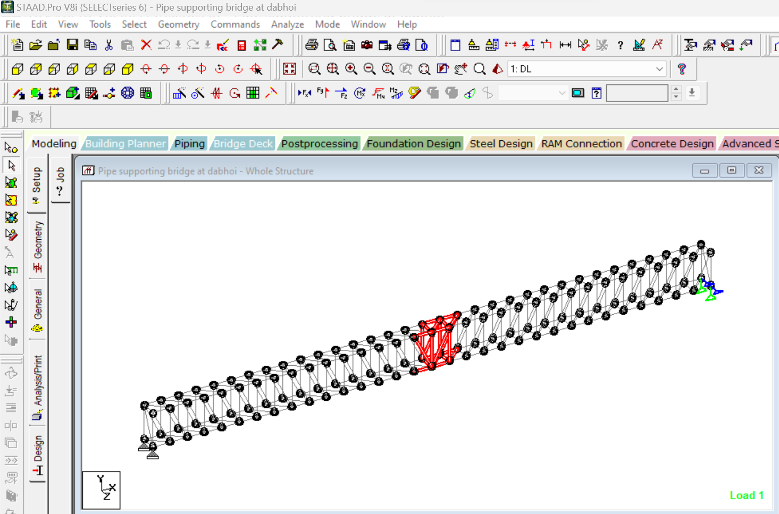

**Figure 2: A sample picture showing selected members in model of a steel bridge structure**

-> After ensuring the above steps, the user needs to click on “Calculate Strain Energy” button to compute the maximum total strain energy (i.e., maximum out of all the load cases) for all the selected members (refer highlighted button in Figure 3).



**Figure 3: Click “Calculate Strain Energy” button**

-> Once the calculations are done, user will be presented with the maximum strain energy in the GUI along with the corresponding load case (refer highlighted part in Figure 4). The units for strain energy will be kN-m or kip-in based on whether the user has selected “English” or “Metric” units in STAADpro software.



**Figure 4: Results**

**References:**

Beardmore, R. “Notes on Strain energy”, <https://roymech.org/Useful_Tables/Beams/Strain_Energy.html>

Kudvenkat, “BackgroundWorker Class example in windows forms application”  
<https://www.youtube.com/watch?v=TwlO5XYeeMo&ab_channel=kudvenkat>

Allen, S. (2022, Sep 26)) “Background Worker”  
<https://www.dotnetperls.com/backgroundworker-vbnet>